**Homework 08: Quantum Dynamics III**

**PHYS550 – Quantum Mechanics I**

**Gabriel M Steward**

**November 14-, 2021**

***Additional Texts Referenced: Introduction to Quantum Mechanics, Griffiths and Schroeter***

**Problem 2.14**

*Consider a particle subject to a one-dimensional simple harmonic oscillator potential. Suppose at t=0 the state vector is given by*



*where p is the momentum operator, a is some number with dimension of length, and the state*  *is the one for which . Using the Heisenberg picture, evaluate the expectation value for t≥0*

In the Heisenberg picture we need the time-dependent form of the operator x. This is provided to us by 2.166a:



To find the expected value we enclose it by our given state vector.

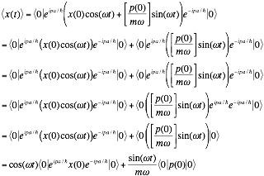

The second term (the one with momentum) is the expected value of p with respect to the “0” eigenket, which we are told is zero. So we are now left with:



Let’s take the term in between the bra and the ket and apply 2.168 to it.



The commutator of p and x is known, [p,x]=-iћ. Trying to commute this with anything results in zero since –piћ+iћp=0. Then everything after that is always zero, so almost all of our terms vanish and we are left with:



So we plug back into our original relation.



As with momentum, we know the expected value of x with respect to “0” is zero. This means…

|  |
| --- |
|  |

Which means it oscillates up to a maximum of a, which has units of length so this is perfect. Clearly, a represents the amplitude of the oscillator. Now, while at first this seems fishy—wasn’t the expected value of x zero at t=0? Yes—for the 0 eigenket. The expected value we were finding was *not* for the zero eigenket, but the unusual eigenket we were provided. Thus, the answer makes perfect sense. We can state that our unusual eigenket represents the state where x is at its maximum at t=0.

**Problem 2.15**

*a) Write down the wave function (in coordinate space) for the state specified in* ***Problem 2.14*** *at t=0. You may use*



As a reminder, the specified state is:



The wave function would be given by:



Let us take the left side of this relation and conjugate it:



Now, while it will seem somewhat esoteric, we want to operate on this with x.



Let us say that this argument is part of a commutator and. Thus we can replace it with



The commutator of anything in the form [x,G(p)] is iћ (∂G/∂p) which gives us



The x operator becomes x’ as it is acting on the x’ eigenket.



Note that this means:



Which implies



Which means we can now say



Which we can subsitute directly into the equation for the normal position wavefunciton to get:



If we substitute in our x0 we get the answer.

|  |
| --- |
|  |

*b) Obtain a simple expression for the probability that the state is found in the ground state at t=0. Does this probability change for t>0?*

This is rather simple. The probability formulation for a specific state is known. If we let out provided original state be alpha…

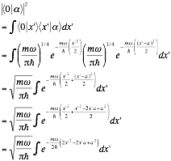

Wherein we could simplify and evaluate… or use the fact that this is a known Gaussian integral form and work from there. This gives us…

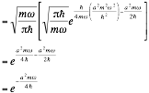

Which, itself, is a Gaussian that depends on “a” and has a probability 1 at a=0, as it should.

|  |
| --- |
| Probability of ground state: |

**Problem 2.16**

*Consider a one-dimensional harmonic oscillator.*

*a) Using*



*evaluate  and .*

The equations 2.146 contain the answers for the first two evaluations, but let’s evaluate it manually as the problem implies we should. Thus, we start with 2.145 for x:



Sticking this inside the bra-ket notation we get:

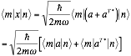

2.144 gives us the evaluation for the a operators:



Which is our first answer.

|  |
| --- |
|  |

As noted during lecture if m=n then we have a case where this is simply zero.

We then do the same thing for momentum p.



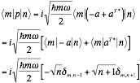

|  |
| --- |
|  |

Next we have {x,p} which is equivalent to xp+px. This is not a commutator so we can’t just say we know what it is, but perhaps with our “a” operators we can figure it out.

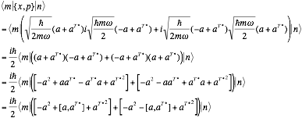

The commutator of the a operators is known to be 1.

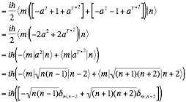

|  |
| --- |
|  |

Next we find x2 in terms of the a operators.



Unfortunately unlike the previous one we can’t just say “the commutator is one” and be done with it, we’re going to have to evaluate the entire thing.

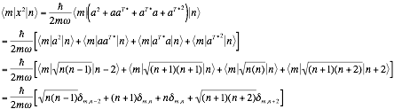

|  |
| --- |
|  |

Note that this one does *not* automatically equal zero when m=n, which is to be expected for a squared observable.

Now we do the same for momentum.



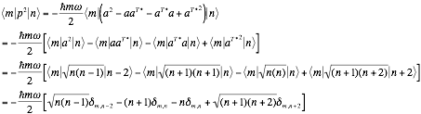

|  |
| --- |
|  |

*b) Translated from classical physics, the virial theorem states that*



*Check that the virial theorem holds for the expectation values of the kinetic and the potential energy taken with respect to an energy eigenstate.*

Given the context of this problem, it seems most likely that we are being asked to use the 1D version since we are in a simple harmonic oscillator in one dimension. The only “unknown” quantity here is V, which is the “potential energy.” The Hamiltonian, being kinetic plus potential, has this in it. Kinetic energy depends entirely on the momentum, so the other term must be V (the part relating to Hooke’s law). Thus:



So if we take the derivative the virial theorem becomes:

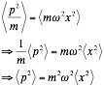

We found the general m,n case in part a) of this problem. The expected value just occurs when m=n. Most of the terms vanish when m=n, save for the middle ones. This gives us…



Which definitely confirms the virial theorem in the case we outlined in part a).